Project UK Fisheries Improvements Stage Two: Nephrops
(Facilitated by the MSC)

Monday 17th June 2019 11.00 – 16:30
Macmillan Room, Mansion House, Edinburgh Zoo,
Edinburgh EH12 6TS

Attendees
AB Andrew Brown Macduff
AC Annika Clements Seafish NI
BH Barry Harland Whitby Seafood
BL Bill Lart Seafish
CB Cass Bromley Scottish Natural Heritage
CD Calum Duncan MCS (LINK)
CM Cameron Moffat Young’s
DW Daniel Whittle Whitby Seafood (chair)
HW Harry Wick NIFPO
MM Mike Mitchell M&S
MP Mike Park SWFPA
SM Sheona McCormack Associated Seafood
WD William Davies Seachill

FN Fiona Nimmo Poseidon
PM Paul Medley Independent consultant

EP Erin Priddle MSC
JP Jo Pollett MSC
MB Matthew Bamping MSC (Minutes)
KA Karen Attwood MSC

Dial In
AD Ally Dingwall Sainsbury’s
AJ Aisla Jones Coop
CM Carlos Mesquita MSS

Apologies
Amali Bunter
Jemima Jewell
Malcolm Morrison
Richard Luxmoore
Stuart McLanaghan

Welcome and Introductions (DW)
- Intro and welcome from Dan Whittle
- Round the room introductions
- Divided times – moving from debate to dialogue
- Open to listening rather than thinking about your response first and foremost
- Try to find consensus
- Recent learning and good at finding cooperation

Minutes and Action Points (JP)
- Minutes circulated, thanks for feedback, as no further comment they will be signed off
- Action points to address
- The group were asked to consider a sub-group for environmental actions (P2) in order to track actions forward between meetings

Recap of FIP Structure, how it works, and timelines (JP)
- Quick review of FIP format
  - Pre-Assessment now signed off -> snapshot in time and now finalized
  - From now any gaps and info to be sent to JP and FN and circulated
  - V1.4 of Action Plan coming out of Pre-Ass as gap analysis
  - BMT – 5-year plan (currently at Y0) each red/orange links to specific action for the FIP
- Hopeful that AP to be signed off today – current snapshot in time and can be flexible
- Sub group formation
  - Idea due to the size of the full steering group
  - Some actions won’t be able to be moved forward due to the unwieldy size of the full group
  - Consider which actions may be best in a sub-group format
- DW – MSC certification is just one of the positive outcomes that may come out of this FIP
  - Gold standard and customers ‘hot’ on MSC certification
  - Lots of positives can be achieved without going through MSC cert at the end of the day
- Regional based sub-groups. Any thoughts and comments
  - MP – lots of duplication that might occur as a result of geographical split
  - JP – any decisions are made by group, not by MSC

Update on the Landing Obligation (MP)
- LO implementation continues
- EU Commission seminar in Brussels last week- good opportunity to feed into discussion
- Look for ideas moving into next reform of CFP
- Compliance concerns mean focus on electronic monitoring
- Joint draft recommends Western Waters MAP
  - TAC for no-quota species
  - Raft of measures put in place for bycatch reduction measures
    - Mesh panel implementation in the Clyde etc.
    - Fleet continues to try and improve its bycatch reduction
    - Now getting to pinch point of economic barriers – loss of economic fish
- HW - Perception that LO is just stopping catching small fish?
  - Hard to square this circle
  - Can’t enforce LO offshore
  - Moving situation offshore where it cannot be monitored
- DW - Sustainable discarding?
  - De minimus – up to 5%
  - LO is what it says = ban on discards
  - Some EU member states approach differently
    - Netherlands – government retains additional quota
    - UK allocates all quota and top up to fleet
    - Not the most joined up approach
- Remote Electronic Monitoring (REM)
  - WWF cameras on all vessels – complex mixed species would shut down fishery too early. OR
  - run as you currently are – may cause short term harm to fishery
- European industry less pro-REM?
  - Sweden only country that is really pro
  - Trial running in Denmark
  - 64 applications for cameras in Scotland
  - Against cameras on vessels pre-regulations being sorted out
  - Might shut down the fishery prematurely

Action 1: Stock Status (1.1.1); Action 2: Harvest Strategy (1.2.1); Action 3: Harvest Control Rules (1.2.2)
- Presentation by Paul Medley, who was commissioned to speak with industry to develop an alternative to functional unit management by TAC.
- Nephrops Harvest Strategy and issues raised in pre-assessment
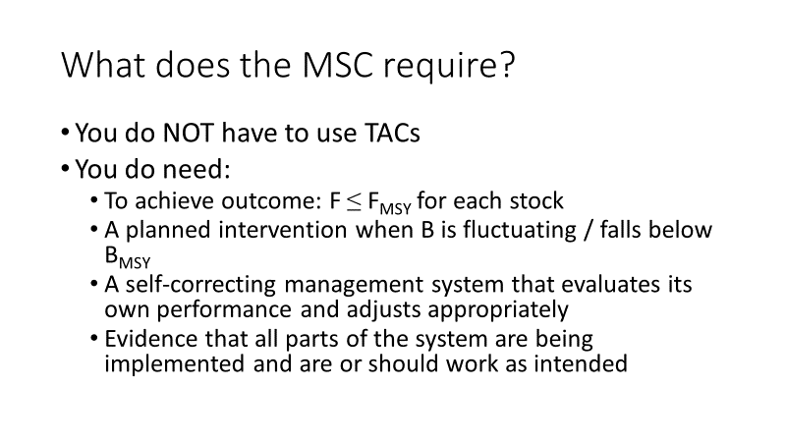
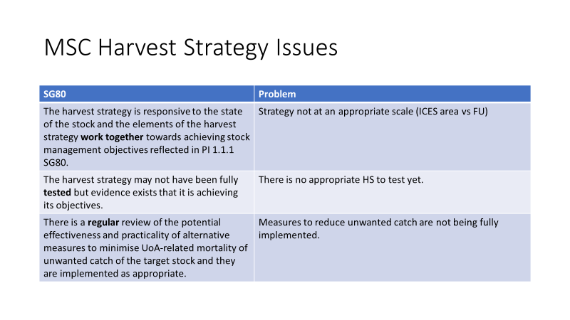
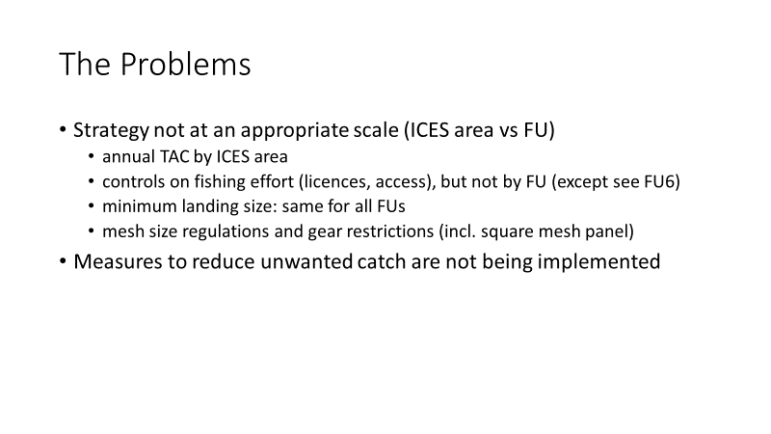
- Project a bit delayed but this is an update of where we are currently up to- not a finished product, and this is a good opportunity for stakeholders to feed in and ask questions:
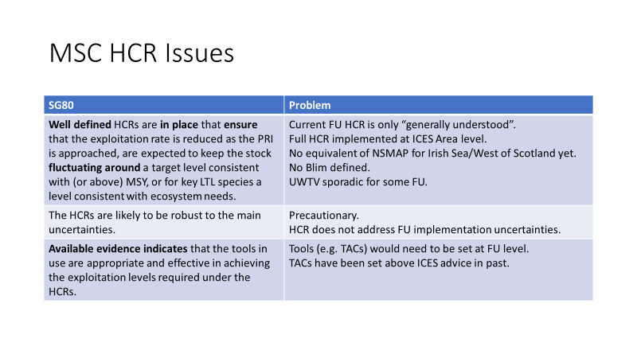
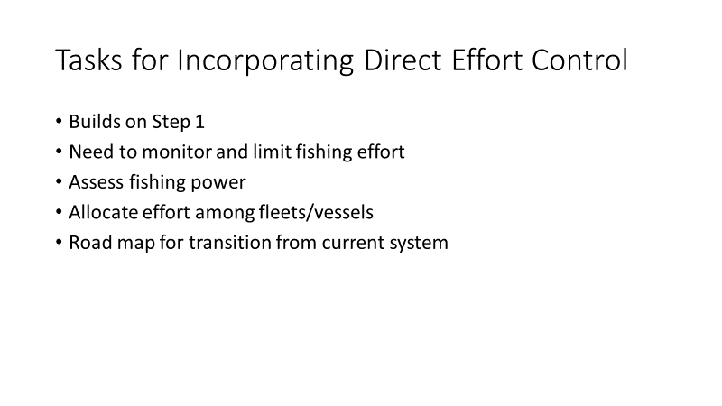
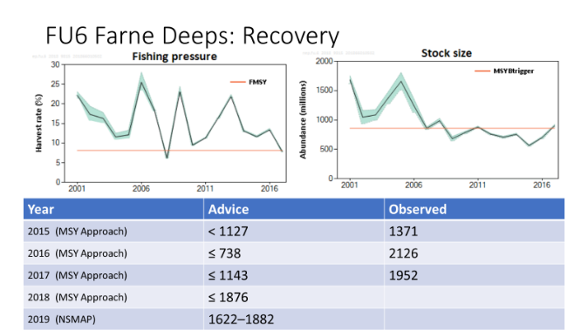
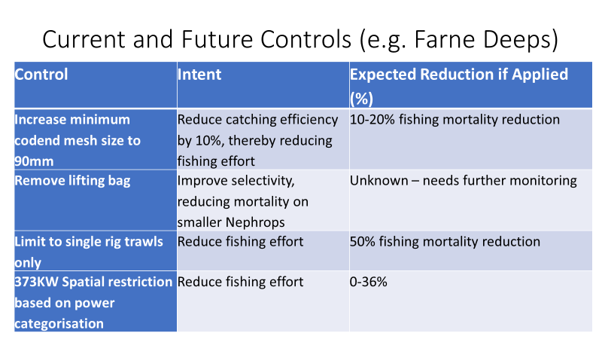
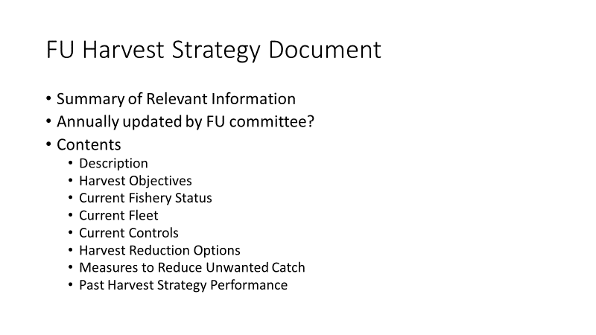
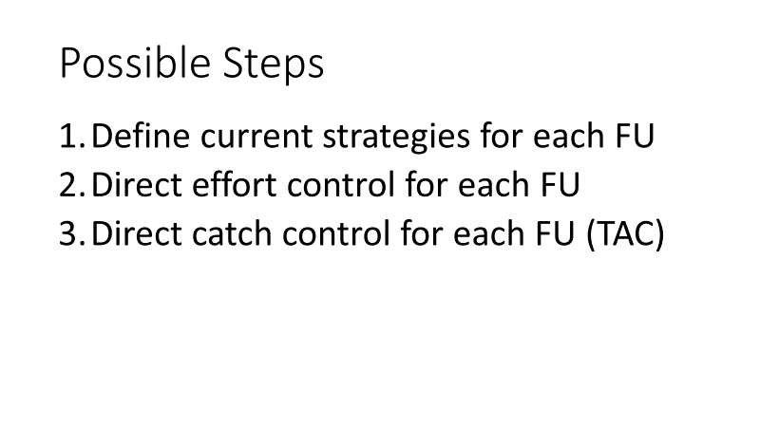
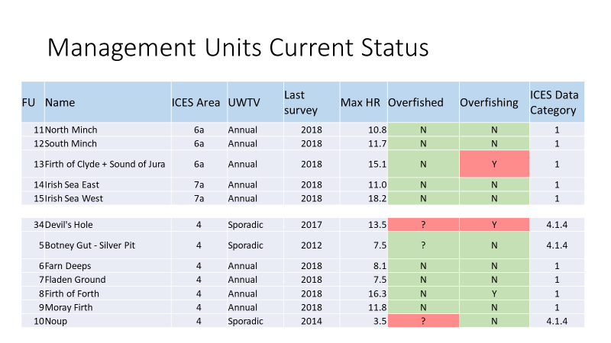
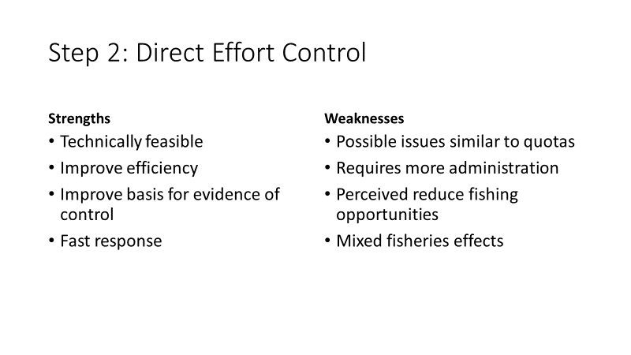
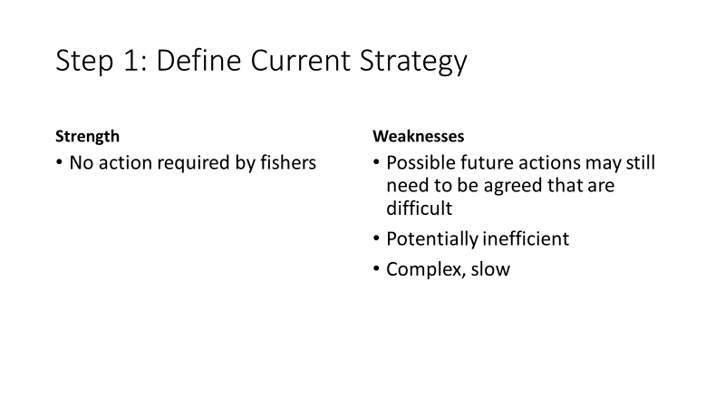
- Primary problem is Harvest Strategy – TAC set at ICES level, but fishing effort controlled at FU level
- It is therefore possible to overfish individual FUs while still meeting the ICES TAC
- Measures to reduce unwanted catch – Nephrops discarding
- Current strategy not appropriate for this scale
- Assessments occur on FU specific basis – limited control of exploitation and missing Limit Reference Points
  - Point at which there is risk of recruitment failure
- Not sure whether HCR is robust to uncertainty or not
- What does the MSC require?
  - Do NOT have to have TACs- lots of fisheries in MSC program not run against TACs
  - MSY is definition of sustainability according to MSC
  - Must have a planned intervention if stock falls below MSY – recruitment falls and therefore so does biomass
  - Self-correcting management system that can adjust itself
  - must be evidence to prove that these things are in place and can be proven to work (may be gained from simulation)
- Status as last seen (to be updated soon)
  - FUs almost all not overfished (according to biomass level)
  - Some FUs are data poor as they don’t have underwater surveys annually
    - Creates additional risk
    - Some of these may be small areas and not worth annual survey
  - Generally good FU stock status – someone doing something right
  - What additional must be put in place?
- Possible steps may just need to undergo the 1st
  - Define current strategies for each FU
  - Direct effort control for each
  - Direct catch control for each
    - TACs not an option
    - Only included because there is a TAC at an ICES level
    - Will not be introduced short term and are not required by MSC
Step 1 – Define current Strategies for each FU
  - Comes down to documentation
  - For each FU must define how, why and who is fishing and what limitations there are
  - Advantage – no action required by fishers themselves (apart from possibly any FUs that are overfished)
  - Weaknesses – plan for future actions – Farne Deep case study (may implement inefficiencies into fishery; might be complex and slow to respond)
- FU Harvest Strategy Document (example to be shared round)
  - Summary of relevant info and would be useful for MSC certification to hand to assessors
  - Descriptive section, objective section, current fishery description, list of vessels, current controls, harvest reduction measures (in line with MAP in Farne Deep example), measures to reduce unwanted catch, past management performance (review of what’s currently occurring and what might be going wrong and how can this be addressed)
  - This should meet the MSC requirement (if the evidence can be assembled)
  - No need to put in new management if you can prove that what is currently implemented is ok
- MP – need to align what’s being said with the wording in the Action Plan
ACTION: MP and FN to edit wording in Action Plan
- FMSY links to current harvest rate
- If rate reduced below B-lim then this is triggered
- Point 2c is a proxy for FU management
- Recommended catch from ICES not a TAC
- What is current harvest rate (currently alright and should be safe going forward – as long as this is continued, should be ok)
- This is currently happening and is being applied by ICES for their catch recommendations
- Bottom line is to evaluate how well you are doing against these recommendations
- Aim is to fish at Maximum Sustainable Yield
- Is an average across a number of years- ‘fluctuate around’
- Definition MSY has been changed to take this into account
- MSY is the level at which you can fish sustainably, taking into account uncertainties
- Does have some fluctuation built in to account for year on year changes
- Preferably below as this is safer
- ICES harvest rates are pre-cautionary and reasonably justified
- If above harvest rate by more than X for X number of years then we have a problem, but if not then its ok – graduated approach
- BL – Nephrops in North Sea have FMSY bands now- will have buffer band in place to try and be in this
- These are details to be discussed per FU
- Variety of reference points for FMSY
- Range gives flexibility and a target, rather than a limit
- MP – ‘everything’s reasonably ok as long as we carry on what we’re doing’
- Currently (assuming things don’t change) then, for the majority of FUs, as long as fishing mortality is within appropriate range than things are ok
- Monitoring and adjustment if required would be sufficient to define a strategy
- If things were to change then they would have to be passed through some form of assessment
- PM going back to MSC requirements to try and create sustainable fishery with minimum impact on fishermen’s livelihood
- CM – is this your opinion and could it be viewed differently to a different assessor?
  - Must advocate why you believe your fishery is sustainable
  - Pull together the evidence that proves this to assessors
  - MSC is not telling you how to run your fishery, just setting out guidelines for evidence that needs to be seen
- For Farne Deep example there is already a Harvest Strategy but currently not enough evidence
- MM – terminology but basically must document the status quo and why this seems to be working currently. Structural issues may mean that most FUs are fished sustainably
- How do we turn this documentation into a management process, how do we adapt to change etc. – adaptive process rather than just documentation then becomes a strategy
- What about those FUs that are currently red?
  - Document sets up objectives and closes circle of feedback
  - Must tick all MSC boxes for each FU
  - Documentation is the 1st step
  - MP – FU TACs are the main concern – POs would not be willing to enter into anything that disrupts current allocation
- Current/future management controls
  - Not well documented
  - Number of controls proposed for Farne Deep, with their intent and expected reductions
  - To change the way the ground is fished and to dissuade some fishers from going there
  - These reduce fishing mortality and therefore meet what MSC is asking for
  - None of these are particularly appropriate for Irish Sea
  - Not solving a problem just moving it elsewhere
  - These were just proposals for Farne Deep
- SDCF’s response to plan was fairly negative and suggested measures wouldn’t go far enough
- FU management proposed by European Commission
- Huge amount of work needed at FU level
- MM – have we answered the question around AP wording? Hope to sign off action plan today but if we could agree that some re-wording is needed then can there be sign off later
- Series of potential steps – This is first step, which MIGHT not meet MSC requirements and then direct effort controls might be required
- This could be written as a strategy – reviewing current status, if found to be ok HS not required, those that need work then have controls implemented and reviewed
- Talks generally about the stock currently- just needs some clarification and slight re-wording
- Without committing to putting in hypothetical management if a breach of FMSY is reached
- Don’t necessarily need to include always fishing against MSY, focus was moved to harvest rate
- BL - NS MAP has range of MSY and states ‘there will be measures’ in fall below this level, but not specific as to what these are
- Farne Deep Case study
  - Fishing pressure fell to below target
  - Net 13% reduction in fishing effort and stock size grew to above the Btrigger point
  - Harvest rate was declining anyway
  - Observed ICES landings are well above advice
  - Underwater surveys used to set next year’s catch recommendations
  - Analytical model not being used
  - Combined package of measures introduced in 2016
  - Effort reductions in over 10m vessels, however under this there was an increase in fishing effort
  - PM concern – these interventions to discourage effort are essentially a hardship to the fishery and are a decrease in efficiency
  - Don’t get larger Nephrops by moving to larger mesh size, just fewer of them = loss of efficiency
  - As short-term solution that was acceptable to industry this might work but still a question of can we do better than this
Step 2 – Direct effort control
- Strengths – technically feasible; improved efficiency; improve basis for evidence control; faster response
- Weaknesses – requires more admin; run into quota issues; possible reduction in fishing opportunities; mixed fisheries effects- can get complicated and difficult to manage
- Tasks for incorporating direct effort control
  - Builds on step 1
  - Need to monitor and limit fishing effort (for some vessels, not necessarily all)
  - Assess fishing power etc.
  - Allocate effort among fleets
  - Roadmap for transition from current system
  - Possibility that is technically feasible
  - This will be fleshed out by PM but can then be taken forward by others if it moves out of his area of expertise
- MP – word of warning: days at sea are proxy for TAC, best to avoid as opens up pandora’s box of issues
  - More myopic look
  - About the feasibility of achieving sustainability in the quickest and best way
  - Sustainability is about the long term – this may lay the ground rules out
ACTION: Paul to meet with POs (and others) and see what their requirements are against the MSC standards.
- BL – moving in the right direction from historical point of view
- MM – Would be mistaken to be overly prescriptive in AP- must allow for different strategies to be developed in different FUs
- Any updates from MSS, Cefas or AFBI (Carlos)
ACTION: Carlos to circulate table of updated numbers of discards from last year
ACTION: Request data on MCRS from Ewen and Carrie
- Survivability exemption for Nephrops
- FU 8 stands out, any explanation?
  - High density area where Nephrops are smaller
  - Historically high discard rates – survey shows this
- MP - Are they above the minimum conservation size?
  - Because they are damaged
  - Don’t current record reason for discard
- Leads onto Action 2D to limit discards of unwanted catch
  - Not a specific target but must be considered and appropriate management implemented
- Just for the trawl fishery- for creel fishery there isn’t must coverage and there is estimated 100% survivability

Action 4 Information and Monitoring (1.2.3) (MSS/Carlos)
- Currently undertaking summer survey assessments:
  - FU 7, 11, 12, 13 & possibly 34 & 10 depending on weather
  - Should be able to survey 34 weather this year
- Last time FU10 was covered was 2014 – first to be dropped
- FU 5 is Cefas – not being surveyed this year
- Currently in 60-79 – actions requires getting regular monitoring in place
- FUs of commercial importance given priority over those that have been surveyed less
- FU10 never a priority
- CM: FU5 last surveyed in 2012 – would this still pass MSC assessment?
  - Cefas uses CPUE as indicator of abundance
  - Could be used to fill in between survey
  - The less you catch, the weaker the CPUE but also the safer the FU
  - Alternative is to exclude FU from MSC certification?
  - Might run up against CoC problems but might be ways around it- would it pass with a condition?
- Problem is that there is no plan to assess these low priority FUs
- If last assessment was in 2014, how long would it have to be before you lose confidence in the projected abundance
- FU5 also includes Dutch catch
- Important through the summer
- Discard rate for Dutch fishery is relatively high compared to UK fleet in FU5- shared ground
ACTION: JP to follow up with Ewen re: plans to survey FU5 (how much caught, shared ground?) – is there a way to monitor e.g. CPUE as proxy?

Action 5 Assessment of Stock Status (1.2.4) (MSS/Carlos)
- ICES workshop in October/November to discuss approaches to data limited stocks
- No real update since last meeting
ACTION: Follow up for update from Cefas on assessment of stock status

Action 6 Primary Species (2.1.1, 2.1.2, 2.1.3) (MSS/WoSPO/CIFA)
- No further update since last meeting
- Some concern due to sampling design being created on single species basis
- Design not optimized for other species, just for Nephrops
- Not sure whether data would get anything meaningful
- DW – Whiting advise for WoS for all regions not just Clyde
- Not a priority to undertake this for other FUs
- Discarding of Whiting is a major concern but anecdotally seems to actually be a relatively small problem
- If a request is made, then MS might be able to look into it but it is not something they would otherwise perform
- Landings could be analyzed separately, but discards would be more difficult to work out
- BL – discard reduction plans for no-TAC species, might give some clue as to where discards are occurring
ACTION: MP – some analysis by fleet segment as to who’s discarding what – check whether he can share discard reduction plan for whiting with the group
- Some % are extremely high but small volumes
- Whiting West coast to be benchmarked 2020
- Scottish Discard Steering Group
  - Shape approach to be taken and identify sectors within prawn fleet that can be approached differently
  - 40% of Fladden income is from fish, very different to a fishery with 95% income from Nephrops
  - Allowed focus on recommendations put in by Western Waters MAP
- Calum Duncan represents LINK on Clyde 2020 project
ACTION: Calum to get in contact with Clyde 2020 group chaired by Isabelle Glasgow to find out if some data may be available around catch composition of white fish in Clyde fishery
- MMO Statement about Creeling – under 10s effort about creeling effort? (potential area for concern)
- Trawl and creel under same overarching TAC
- Will have number of licenses but not necessarily a limit on number of pots
- Discussion in Stornoway last week about pot limits
- Gear conflict and conflict for space
- How much product being put on shore – most live
- Difficulties on creel limitations
- Creel representation on group – Elaine for CIFA
- Duncan McGuiness would be good to have
- From MSC perspective P1, creeling is covered under TAC
- Possibly up to 500,000 prawn creels in west of Scotland
ACTION: MSC to reach out to creelers for increased representation on the steering group

Action 7 Secondary Species (2.2.1, 2.2.2) (MS Policy)
- Loch Torridon Creel Catch
- Total catch 48% landed, 40% discard
- Landing statistics do not sound accurate
  - BL – some data may be available
  - Don’t need evidence of survivability
  - 1st stage is to get species profile
  - Originally looked at catch stats, if other stats out there then that would be good
- Worth thinking about sub-group to move this action forward?
  - Depends on what information can be gathered form MS and BL
  - Shouldn’t require a sub group
ACTION: Bill and Marine Scotland to pull together data available on catch profiles and survivability, and circulate

Action 8 ETP (2.3.1, 2.3.2, 2.3.3) (LINK/SNH)
- Sourcing shapefiles – lots of info but not actual shapefiles
  - These need to be gathered from Marine Scotland directly
  - May be gaps that could be filled by SNH
ACTION: SNH to provide contact person for Fiona to access shape files from Marine Scotland
- How were Priority Marine Features considered?
  - Habitat feature components generally treated under habitat or ecosystem
  - Specific features that are protected considered VMEs
  - Invertebrate PMFs considered as ETPs
  - Reef forming inverts within habitat
- ETP sub-group would be very useful
  - Species and habitats blurred – sub-group for the 2 combined
  - Probably same sub-group between Nephrops and Scallops
  - EG would be interested in joining
- Other people to step forward now?
  - LINK would be interested
  - Individual habitat management plans might be steering group specific
  - Discussions to be had around components of PMFs etc.
  - Cannot lose sight of overarching theme of protecting habitats and features
- Different definitions across UK
  - PMFs only Scottish but use wider UK definitions
  - PMFs are species important to Scotland and include commercial species such as Cod & Haddock
  - DAERA held data to be put on EMA net biology
  - Marine Conservation only to 12nm in NI
- LINK – some features of burrowed mud that are of conservation importance that are not protected under MPA network
  - Important to note their position in response to the splitting up of burrowed mud PMF classification
  - From MSC perspective, just because it’s a commonly occurring feature doesn’t mean nothing is needed to be done with it
  - A commonly occurring habitat can still have ecological importance
- Marine Scotland best placed to source shapefiles of distribution of ETP and habitats, with other contact for JNCC and NI
ACTION: AC will follow up on shape files for NI
ACTION: JP to reach out to JNCC for shapefiles in England
ACTION: Set up subgroup to clarify ETP list and document management. Also need a consensus on what constitutes commonly encountered habitats (PMFs, VMEs, burrowed mud)

Action 9 Habitats (2.4.1,2.4.2) (Seafish/MSS)
- Seafish sponsored Mike Kaiser at Bangor- tool that analyzed relative benthic status of habitat
- Look at potential productivity of benthos and how much is disturbed and work out if levels are unsustainable
- Built tool that looked at understanding relative benthic effects of fisheries on different habitats
- Looked at recovery rates – these were to be related to MSC criteria- 80% recovery within 5-20 years
- Looking at building a system to develop this
ACTION: JP to follow up on whether contract is still with Bangor and the progress made so far
- Cefas have same approach for NS P&LS fisheries
- Produced something that gets close to MSC approach but not quite
- Particularly focuses on VMEs
- Tools being developed
- How much more work is needed for Cefas P&LS scheme?
  - Report needs to be linked back to MSC standard
- Jan Hiddink now leading at Bangor
- Methods are there and are getting close to MSC standard
- Bangor method relatively user friendly
- Seabed impacts Project – Mike Kaiser, Ray Hilborn etc.
  - Right approach
  - Good to see what Bangor have
- DW – less than 60 score for Nephrops- we don’t know enough to work out the impact
- Resolution of spatial data important
ACTION: BL to get relative pixel size of data drawn up
- Mike Kaiser Habitat PhD for Scallop might overlap with Nephrops
ACTION: MSC to look into Nephrops trawl fishery in Skagerrak – what did they do in terms of habitats and VMEs - passed certification so must be above at least SG60 for 1.3
- AC – assessed at whole fishery level or at FU
- P2 broken down by gear type
- AC – bottom up approach for Irish Sea Nephrops project
- Working at a course scale
- Regional specific data lost
- Assuming common set of characterized species means there will be a loss of area specific species and habitats
- Flexibility in the Bangor tool

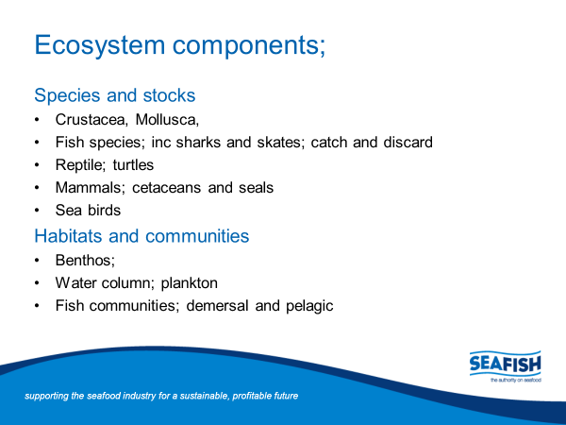
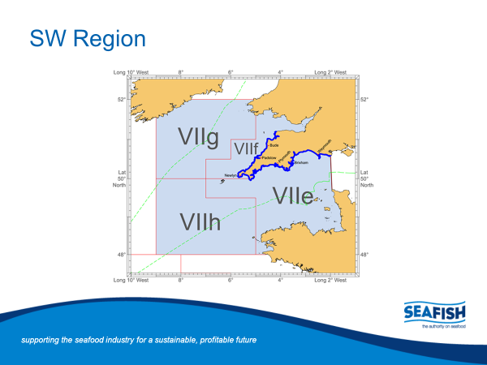
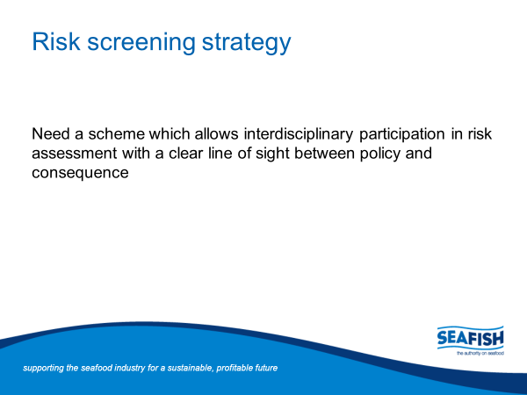
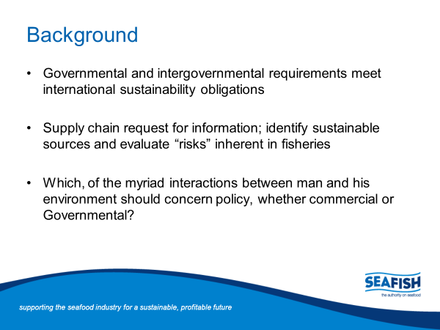
Action 10 Ecosystems (2.5.1,2.5.2) (Seafish)

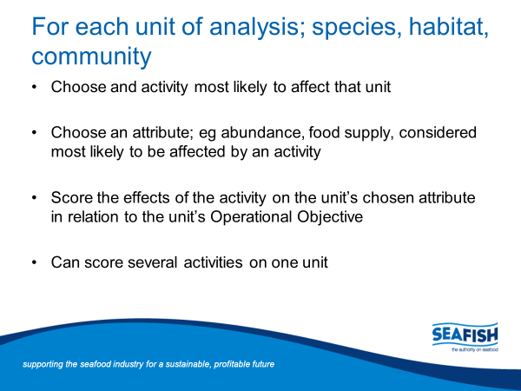
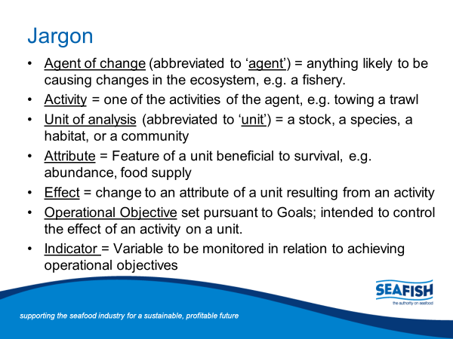
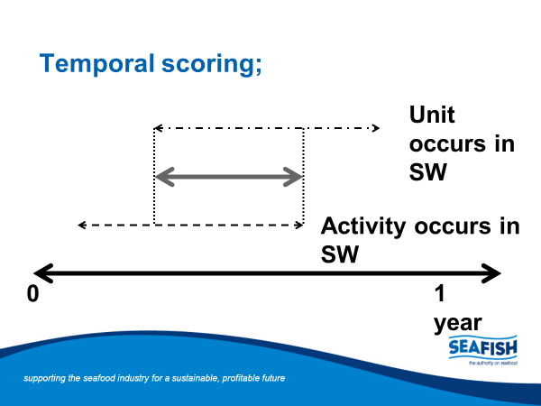
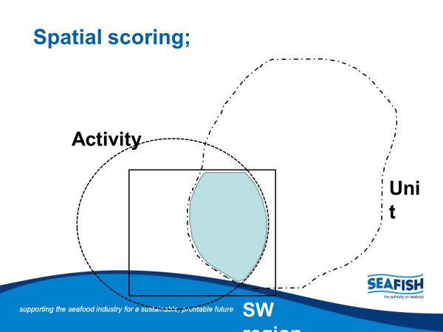
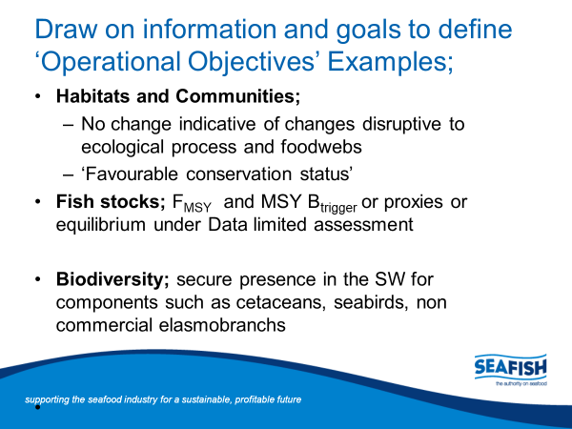
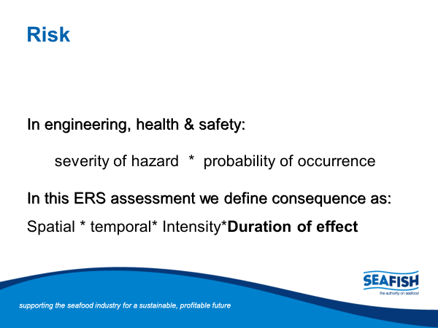

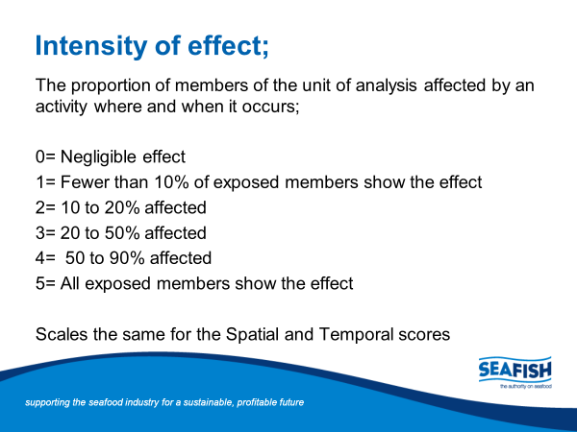
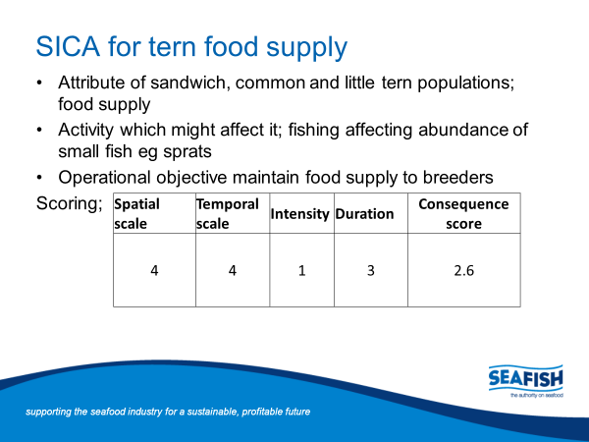
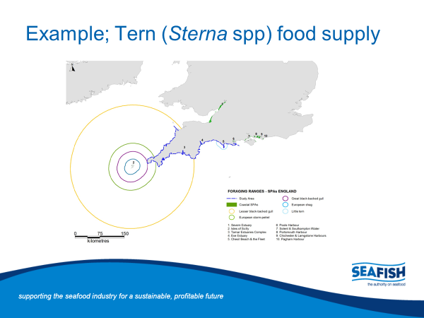
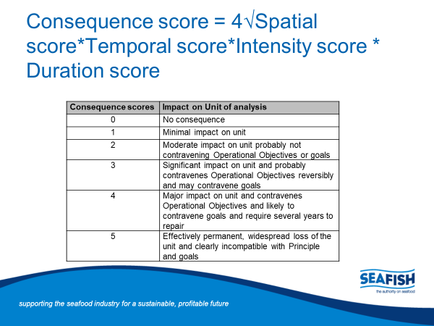
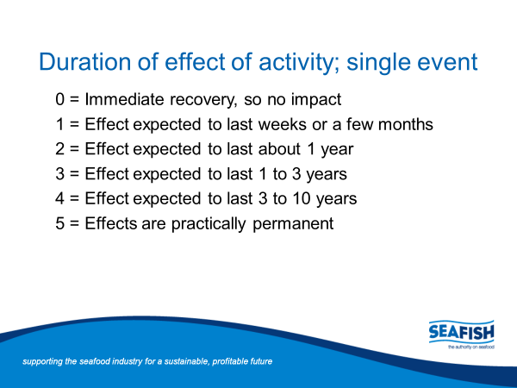

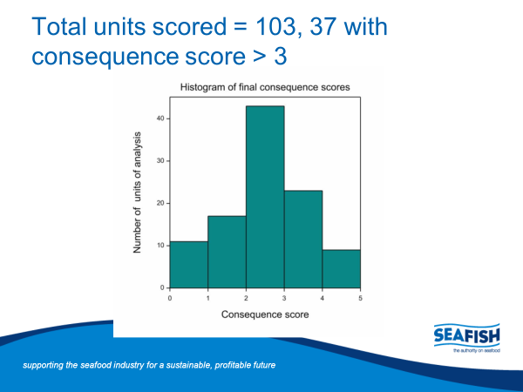
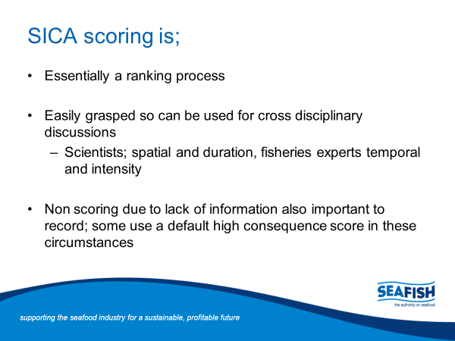

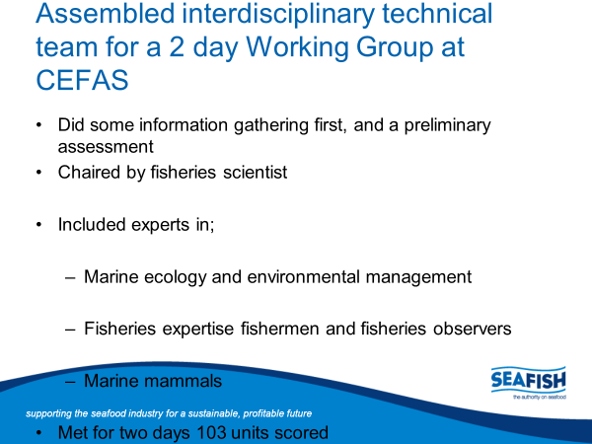
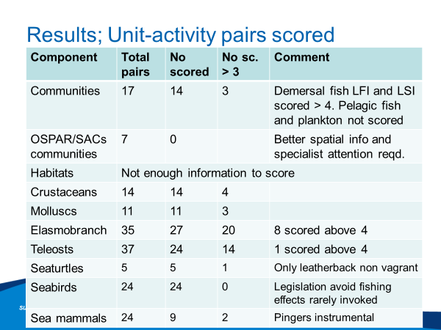

- BL – SICA tool development
- Describes assessment off south west of England
- FN – interesting to see what gears and activities were being looked at
- Effect of fishing on these components
- Was there anything directly relatable to Nephrops trawl?
- Ecosystem component looks at indirect effects, as direct effects are covered in other P2s
- MM – really interesting tool with lots of potential, how scalable is it to PUKFI S2? Who would do it? Who pays for it?
- Stage 1 – EMFF funding for Cefas to undertake SICA
- If BL to lead, then will have to look at different funding methods
- DW – could you commit Seafish to do the work?
- Would have to be discussed
ACTION: BL to go away and cost up Seafish SICA
- EP – learnings from Cefas SICA?
- Lots of hand holding was required so would it be more efficient to use BL given his knowledge of SICA and the PUKFI process?
- FN – would be good to compare the Cefas and Seafish approaches to discuss
ACTION: BL to send FN more info and JP send FN Cefas analysis and then comparison to be made
ACTION: Annika to email details of WK Irish ecosystem modelling on Nephrops
- Not necessarily looking at seabed ecosystem services
  - Seafish SICA wasn’t confident in the data had
- AC – lots of ecosystem modelling being undertaken. Would be good to do a sweep of all current models out there for analysis to occur
  - WK Irish on ICES website

Action 11: Compliance and Enforcement (3.2.3) (ALL)
- Non-compliance with LO and appropriate system for monitoring within MPAs and other closed area
- Discussion ongoing with future fisheries management in Scotland – consultation to close mid-July
- Concern over MCZs in Irish Sea?
  - Currently no management for offshore MCZs
  - 1 inshore management process coming into force but is MMO/IFCA enforced
  - CFP management measures should have been in place for offshore MCZs but no fishery management measures in place
  - NGOs concerned that no management is in place for these MPAs and no timeframe for fisheries management
  - Precedent for zoning and exclusion – thoughts that MCZs will lead to full closure of these sites
ACTION – Need to engage with SCFF and UK FAs

Next Steps
Sub group formation
- Environmental sub-group
- Noted down some people who might be interested and will tie in with scallop meeting for tomorrow
- Given discussion this morning Harvest Strategy should have another sub-group for P1- await results from Paul Medley’s report and then consider next steps

Communications/ Website
- KA to undertake branding exercise
- EP – fantastic work going on but little communication to promote it. Figuring out how much time to dedicate to branding exercise to promote PUKFI at UK level and further afield
- One-off workshop with reps from all steering groups to occur and proposal to be developed and made in autumn

PUKFI governance
- PUKFI has grown substantially since its inception with Stage 1, and now some talk of a Stage 3
- Growing importance of an overarching governance structure in now becoming apparent
- Expansion of scope for other FIPs, and Open Seas wanting to join Stage 2 FIPs
- Next step is to figure out voting system- its up to the steering group to decide how this might occur, but it needs to have agreement so that there is legitimacy around any future decisions
- We don’t want to set a precedent in one FIP that could have implications for other FIPs
- Although we have a ToR, there are no details around the process of how to actually vote on/off SG members
- Balance of steering group is important – could they be asked to feed into one of the sub-groups as a compromise?
- OpenSeas have made it clear they want to be on steering group and are willing to sign the ToR
- Balancing risks between losing other important SG members in place of OpenSeas is important to note
- Need to be sure that anyone entering the group must live by the ethos of working towards the success of PUKFI not its failure
- Collaboration agreement might be developed- clarity on how to communicate during and after meetings?
- Important to protect the data collection and what is being discussed, so it can’t be circulated without steering group agreement
- Consider adding confidentiality into the ToR?
- Important to have a clear structure as to how SG works

Sign off of Action Plan
- FN and MP both redrafted HS section of AP
- MP to send across
- Harry to be copied in in order to clarify
- Other than those, Action Plan has been signed off

Thanks to the group for attending and close of meeting.

